Sonoma Farm Scene – The Winter Market
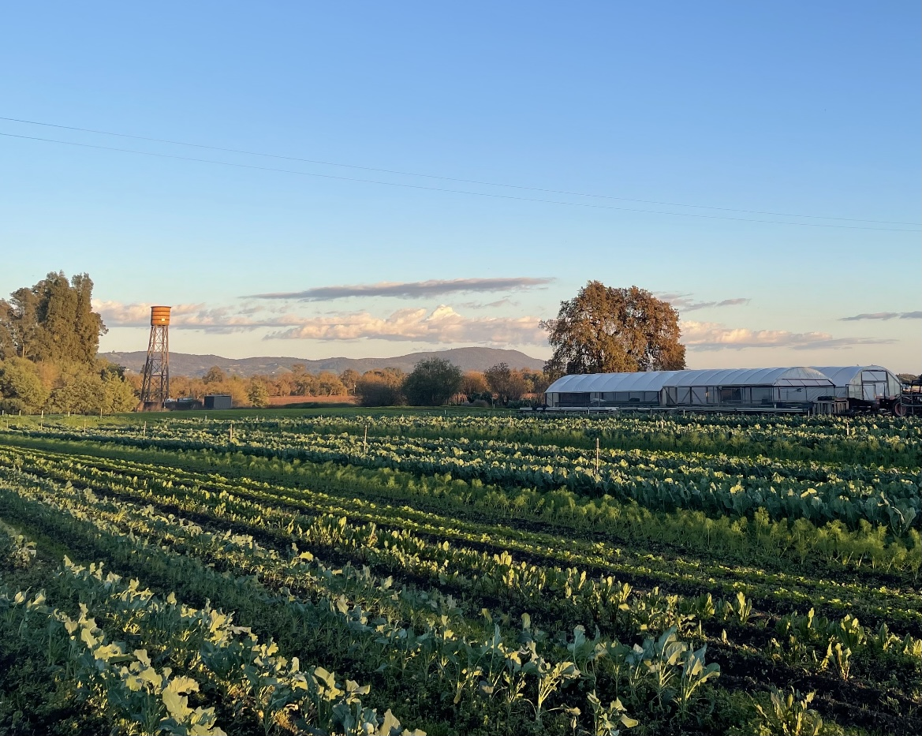
Paul’s Produce on a December afternoon

“Season’s Eatings”
As the days get shorter and the temperatures drop, the end of the growing season for Sonoma Valley farms is upon us. The Winter Solstice is a time when nature retreats and humanity celebrates. With the heady abundant days of summer long past, local farms are near the end of what has been a solid growing season. A visit to Paul’s Produce just off Arnold Drive for a visual reconnaissance revealed the dirt on what’s coming to market for the holidays.

As usual, my inspection yielded exceptionally tidy rows of vegetables, in all shades of green mixed with reds from lettuces and chicory, a reminder of Paul’s skill in growing and managing his crops. There were signs of recently harvested fennel bulbs, with only the outer skins remaining discarded along the bed. There were long rows of brassica’s – broccoli, cabbage, brussels sprouts, cauliflower, and kales – some of which were in the process of harvest, while others, due to successive plantings, were laying in wait for future harvest. I felt a sense of security, as a resident of the Valley, in knowing there was food growing in my neighborhood, and lots of it!

My trip to the Friday Farmers market led to a reunion with Paul’s crops, now harvested and laid out on tables that seemed to go on forever. Going down the line we had lettuce mix, radicchio, arugula, pea shoots. There were the brassicas, next to the last peppers of the season, root vegetables a-plenty, including Paul’s famous carrots. German butterball potatoes, leeks, onions, and winter squash – a true bounty and resource for the home chef. And that was just one booth at the market!

Across the way, the Patch had another impressive spread, highlighted by large tables of purple and yellow cauliflower, large heads of lettuce, beets, squash, beautiful bunches of multi-colored radish, and, incredibly, tomatoes! Owner Lazaro Calderon admitted “This is my last week, I’m going to till in everything before the rain”. He sounded relieved to take a break from the vegetable treadmill that he had been on for 9 months strait. While the Patch will be missed, the slack is taken up by Oak Hill Farm, with their aesthetically pleasing booth, decorated with cut flowers and greens, holiday wreaths, and excellent produce, including: Romanesco cauliflower, turnips, little gem lettuce, Yukon gold potatoes, persimmons, garlic and whole brussels sprout stems.

Loaded to bear with vegetables, I moved to fruit, picking up great mandarins from Gertz farm. “I’ll be here every week” assured orchardist Chris Gertz, “Citrus is coming on strong” pointing to navel oranges, pink grapefruit and Meyer lemons. More citrus was to be had at Rhodes farm across the way, as well as Asian pears, apples, persimmons, and late harvest Crimson table grapes from the Central Valley. I stopped for the micro-greens from Sweetwater Spectrum, some carrots from Ortiz farm, who had impressive holiday wreaths, mushrooms from Sammy’s Bohemian Farm from Occidental, and, of course, bread from Mike the Bejkr, who has a variety of seasonal breads and baked goods, cookies, scones, and incredible kabocha squash chocolate cookies. With so many more booths to go, selling local meats, eggs, dairy, teas and coffee, fermented foods, I realized two things - how lucky we are to have high quality foods available directly from the producers, and… that I had to go back to the ATM. Friday’s farmers market is truly a one stop-shop!

(Seth Dolinsky is manager of the Sonoma Valley Agricultural Cooperative, a program of the Sonoma Springs Community Hall aimed at supporting local farms and food producers using organic methods and ingredients, and is owner of New Land Systems, a regenerative land management company.)

